Node js

Competitor for PHP

1. Node js is not a language
2. This is server run time environment
3. Node js can connect with database
4. Code and syntax is very similar to javascript
5. But not exactly the same
6. Node js is free,open source
7. Node js runs on chrome v8 engine to execute code.

Why we use node js?

1. Node js is mostly use for API
2. So we can connect the same database with mobile app, web app
3. Node js is super fast for APi
4. With node and javascript you can become full stack developer

History—

First release – 27 may 2009

Current version – 18.14.4

Written in c,c++,javascript

Js and node are the same?

1)Syntax is same

2)Node js can connect with DB,it runs on server side

3)Js can’t connect with DB, it runs on browser,device

What is client side and server side?

(Mayur) (google)



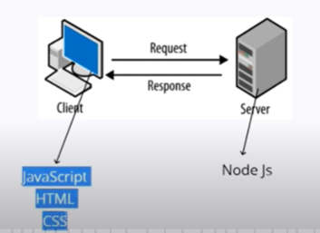



How node js use js?

What developers make with node,js?

1)Developers makes API with node js

2)so we can connect server with client

3)Node can make API for web, android and ios

4)node can make website also

Install and setup node js—

1)Download node js – nodejs.org

2)install npm(node package manager)- to manage libraries, packages for node

3)recommended code editor –

Vscode , sublime , atom , webstorm ,notepad++

Interview question –

Console.log in browser and cmd are same or not?

Ans – not same because one is provided by browser and other one is class with method console.log() of node

Fundamentals of node js - - -

1)node js uses js fundamentals

Difference between js and node

1)we can’t import/export in node like browser/device because node uses older version of js

Export -- 

Import----

Interview question –

Filter()

Core module in node –

Like buffer , http

Global module -- console

Non global module - - fs.__filename

Interview question –

Can we import single file system at a time other than full module

Ans== yes we can



Basic server output on browser—

http module – node js ke ander server ki request aur response ko handle karta hai

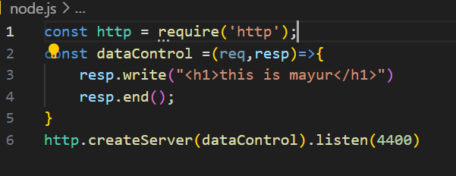

Interview question—

1)function as parameter

2)arrow function

3)http module

All about package.json - -

What? –

Ye project ki details rakhata hai like project name , version , git repository,commands use,dependencies,

Packages , coding related details

How to make it?

npm init --initialize npm

npm install --- jo package. json me dependency hogi use install karega

--To create node modules folder

interview question –

1)node js single/multi threaded –

Ans --Single threaded – eka veles ekach command run karte

2)Jar node modules git var upload karaycha nasel tr –

Ans -Add node modules in gitignore

9)Nodemon package – time saving module

Node js cha project continuously run karat like auto save ,ghadi ghadi (node ./app.js) command run karychi garaj padat nahi

Package ani module ekacha asat

I.Q –

1)node js is sync/async language ?

Ans – async language

Sync – eka nanter ek syntax run hotel (1,2(wait),3,4,5)

Async – jar ekhadi command time get asel tar node ti command sodun pudhe jail and ti jevha complete hoil tevha notification deun deil (1,2(wait nahi karat),3,4), tyamule hi lang fast aahe

Make a simple API :

What is API—

Application Programming Interface ---

1)API is tool for sharing data in application

2)share data between platform by json because json supported all programming languages

3)share data between programming languages

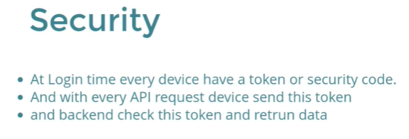

Make a simple api ==

iQ—

what is 200?

Ans – it is status and I have learn different types of status

What is command line?

Command line means in command prompt

Input - -

Syntax -  argv = argument vector

12)show file list with file system

How to create files in node?

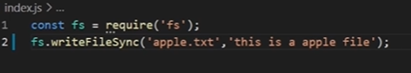 - but it takes much time for multiple files

For multiple files,to create in loop, we use path module

fs – file system- implememt the file I/O operation

fs.writefilesync – it is synchronous method , creates new files if specified file does not exist

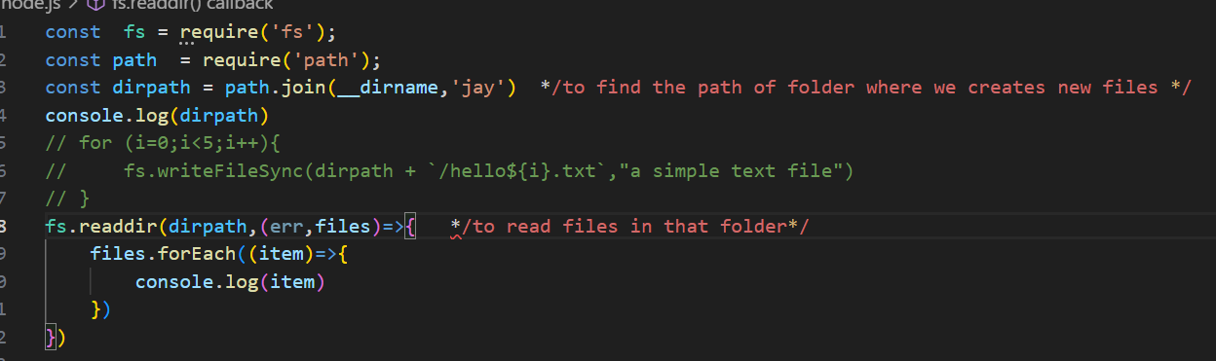

IQ –

Can we access files outside your node running folder?

Ans – No, we can’t

CRUD with file system –

C-create R-read U-update -D-delete

IQ- buffer?

Ans- temporary memory location to perform tasks

Asynchronous basic in node js –

In synchronous operations tasks are performed one a a time

User 🡪 product🡪cities (one by one)



In asynchronous,second task do not wait to finish first task 

Node,js – async php – sync

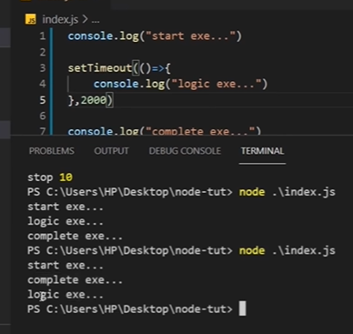

Drawback of async lang –

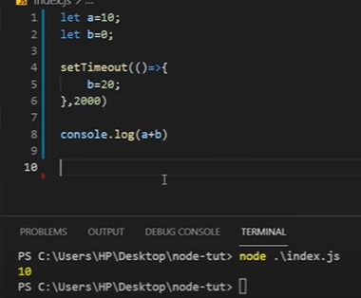

To handle drawbacks of node, we use promise, async await, callback function

Promise –

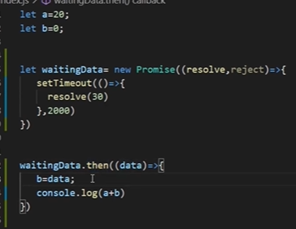

16) How node js works?

Node js architecture – call stack , node api , callback que

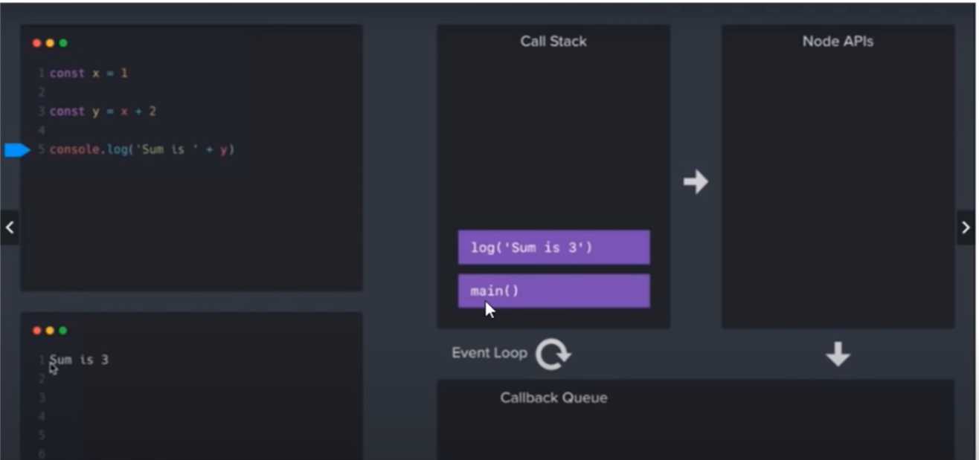call stack – jevde function code madhe aahet ,te sagle register karayche ani one by on eexecute karayche

Saglyat adhi main() function register hoil because te purn programme che main function aahe ani mag console hoil, jyach kaam zal te one by one call stack madhe remove hot jail ani output deil.

Node api – node hi js , c, c++ ne milun banleli aahe so kahi function he js che nasun c++ , c che astat eg. setTimeOut() he c++ che function aahe tymule te call karave lagte c++ madhe tyamule te pahile node api madhe yeil ani mag priority order nusar callback que madhe yeil ani mag finally call stack madhe yeil.ani mag output generate karel

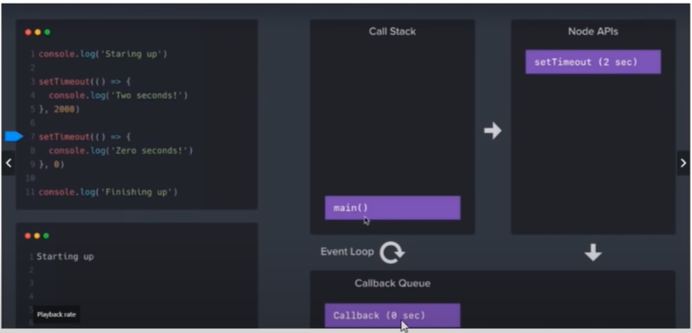 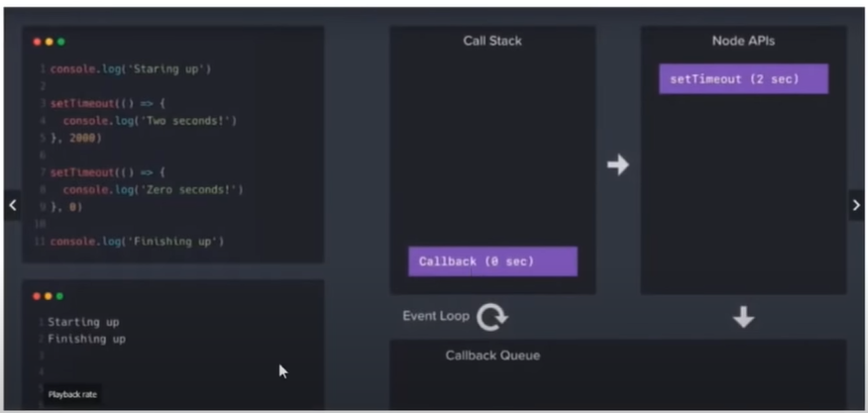

Tip -jo paryant call stack madhe main() function aahe to paryant callback function callback que madhe cha rahtil.

17)Express js - - -

It is framework of node js.

How ro create new page using express?

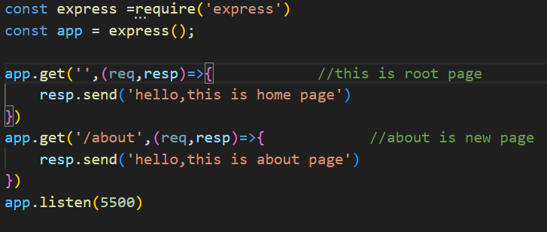

18)Routing with express js ---

Request aur response hota kya hai??

Code in vs code--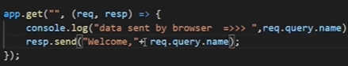

Output in console --

explain – browser chya serach window through request keli ani code through result show kela

render HTml and json ?

render means display karaycha

html -- 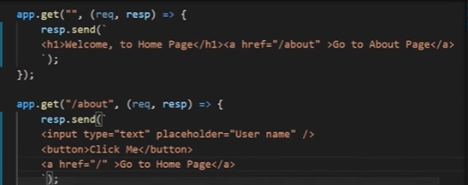

json -- 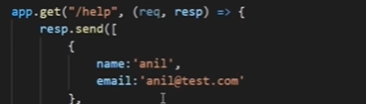

IQ

How to get values from parameter means through browser?

Ans – req.query.name

Make HTML pages –

Html folder madhe apli regular html aste.

IQ –

1)path module –

Ans – project ke folder ko access karne me madat karta hai

2)static method –

Ans- static content ko load karta hai like html

Remove extension from URL – 

Uske liye hame get method use karni hogi like

Agr hame ek by default page rakhna ho jo galat url pe show ho to page address me * daldo

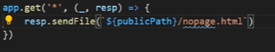

IQ

404 page hota kya hai?

Template engine –props la altenative

Dynamic pages banane me kaam ata hai

Ejs template – embeded javascript template

Install it

App.set(‘view engine’,’ejs’); //to tell node we are using ejs

Data sending data gettng

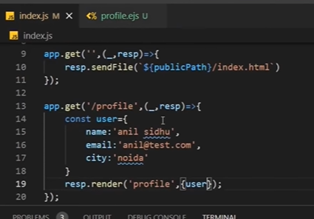

Dynamic page - -

Middleware –

Def – functions, inki help se req aur resp ko modify kar sakte hai.

Middleware sirf routes ke saath hi use kar sakte hai.

Use - req , resp ko filter karna hota hai, authentication ke liye

Middleware types –

1)Route level middleware –

a) single route

b)group level middleware-

2)app level middleware

Route is way taken in getting from a starting point to destination